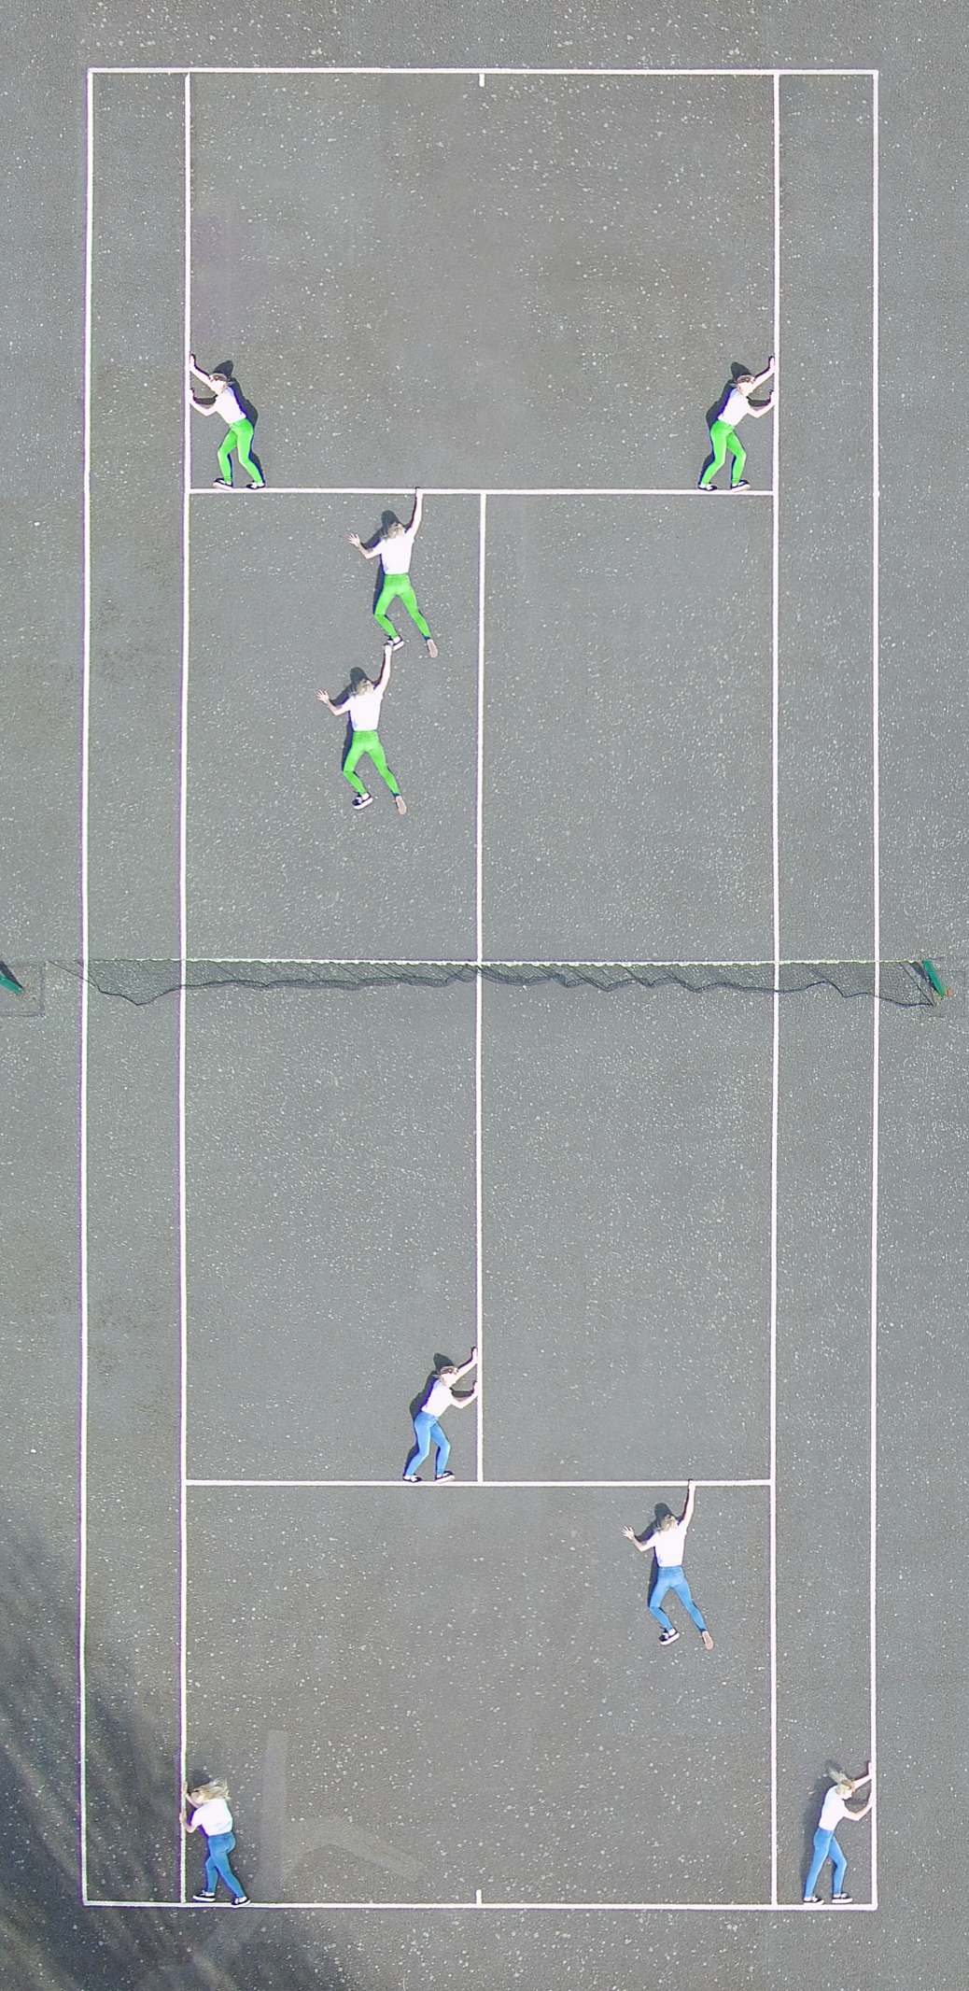

**Explanation of artefact**

This image represents the struggle of wanting to participate in sport but being prevented by your own mind. The symbolization of entrapment shown by the struggle to escape the tennis court boxes emphasizes how difficult it can be to have the confidence to step out of your comfort zone and enjoy playing a sport.

This artefact acknowledges the struggle people face when wanting to try new sports whilst reassuring them that whilst their confidence may be low, or their gut is telling them not to, they must go for it!

**Evaluation of artefact**

To produce this artefact, I had to safely fly a drone over the top of a tennis court within Ghulevelt Park, Worcester. This process involved positioning spotters in sensible positions so that onlookers and members of the public were notified about the flight whilst also monitoring for hazards that could interfere with the flight. This went very well with no interruptions during the flight and hardly any bystanders entering the flight path excluding a dog prior to take off which did lead to a delayed start. To determine whether the flight was safe, several checks were done against a pre-determined checklist that covered everything from drone checks to equipment checks and even weather checks. **[See Figure 1, Figure 2 & Figure 3].**

Once the checklist was completed and spotters were in place, the model was instructed as to which positions, she should pose in for the best outcome and how I would communicate with her as to when to move. In hindsight, this should have been planned prior to the flight day as this would have reduced delay and helped coordinate position changes more efficiently.

The flight plan seemed simple as once the drone was at a significant height it would sit above the tennis court and take several photos with the model in multiple pre-determined positions. However, adjustments had to be done to fit in as much of the tennis court as possible whilst also avoiding low swinging branches of trees and the high fence.

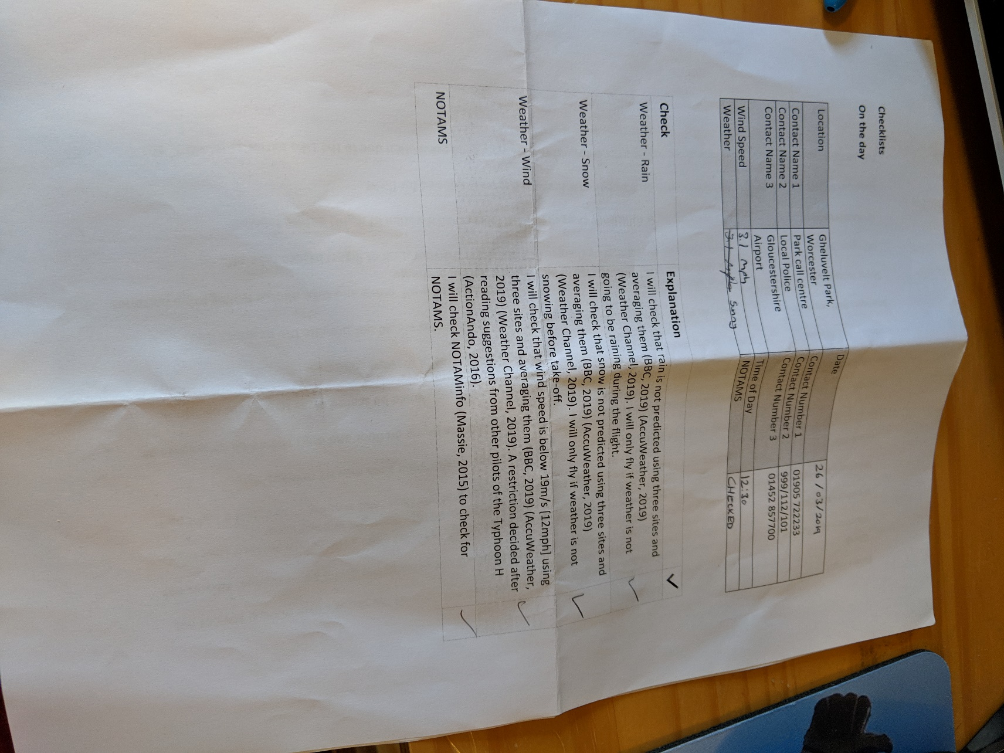

Figure 1

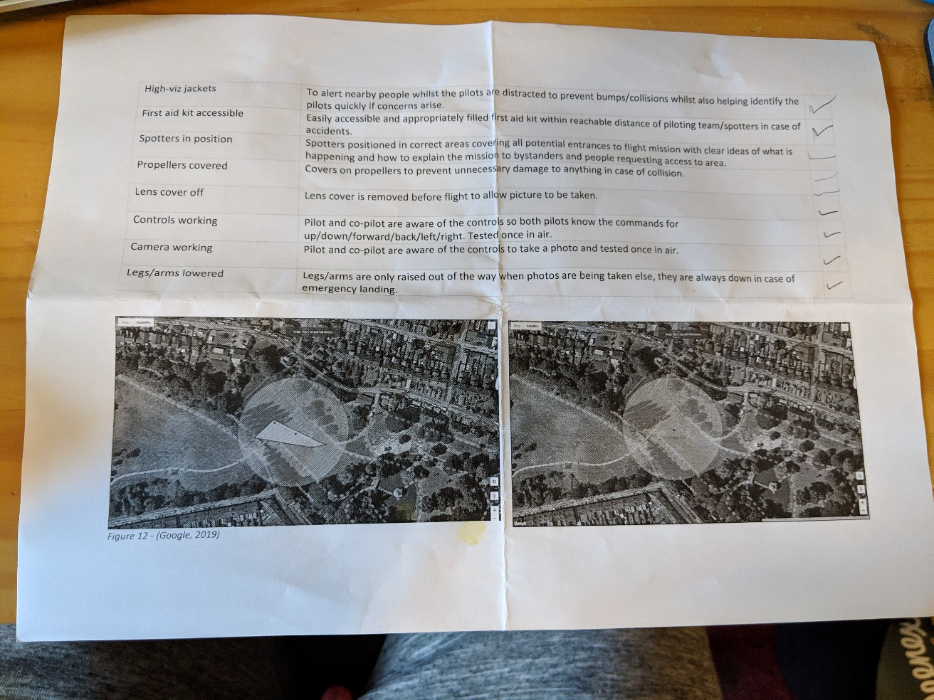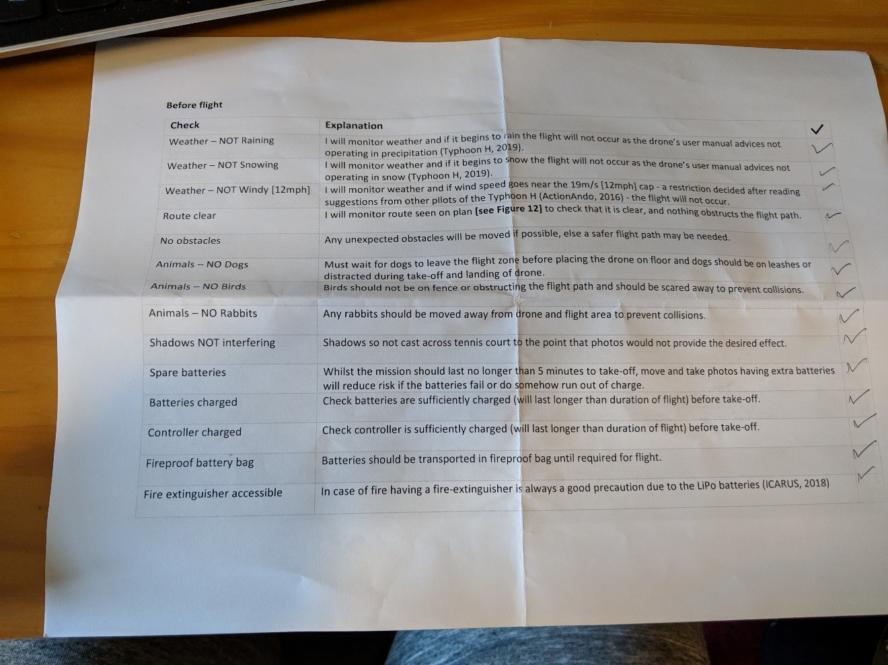

Figure 2

Figure 3

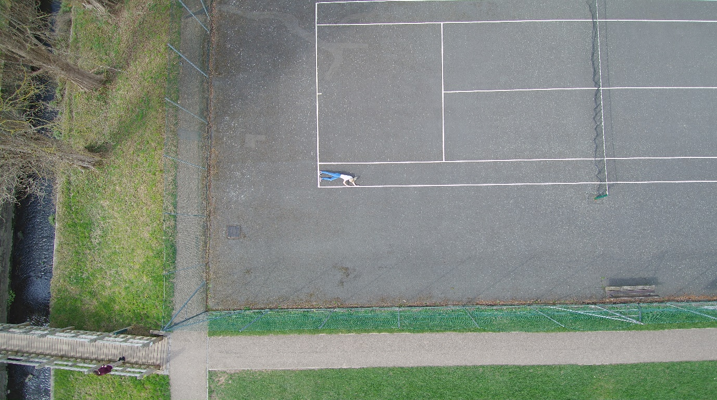Additionally, the drone had to keep a good distance away from private houses and gardens but be close enough so that the pictures were high quality, detailed and to capture as much of the court as possible. The model was positioned on the floor within the tennis court acting trapped amongst the lines, firstly pressing against the outer line **[see Figure 4].**

Figure

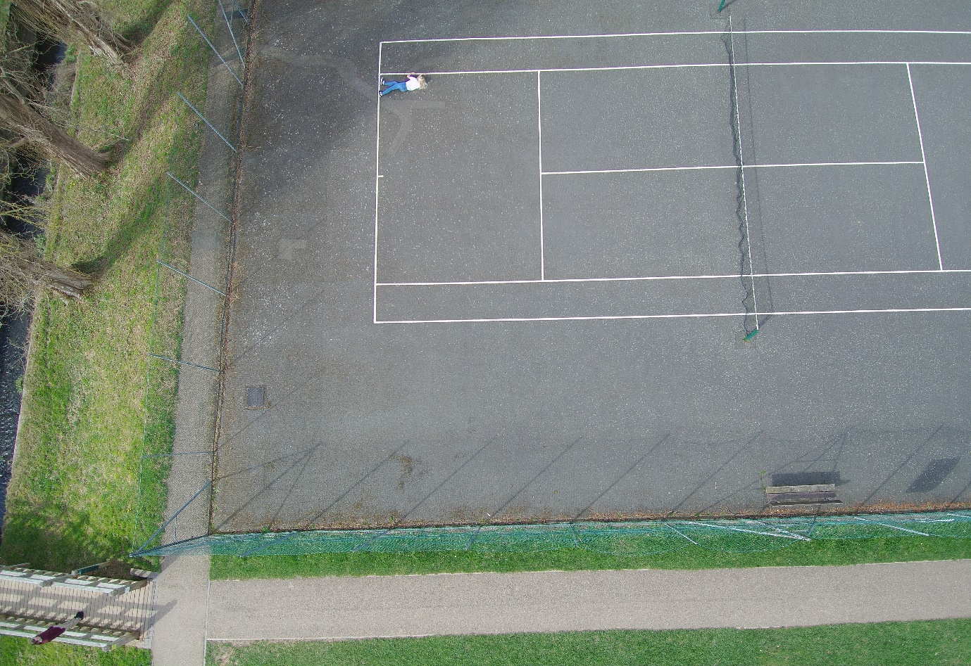Then against the opposite inner line **[see Figure 5].**

Figure

Next, she pretended to hang from the horizontal line **[see Figure 6].**

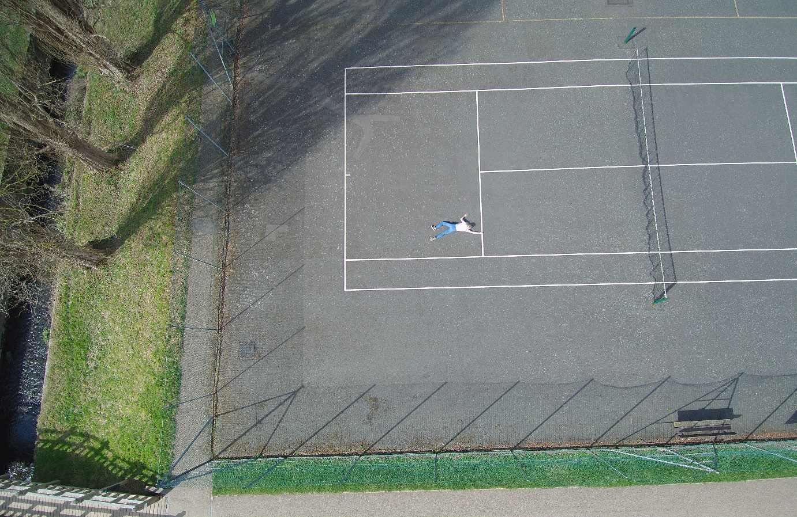

Figure

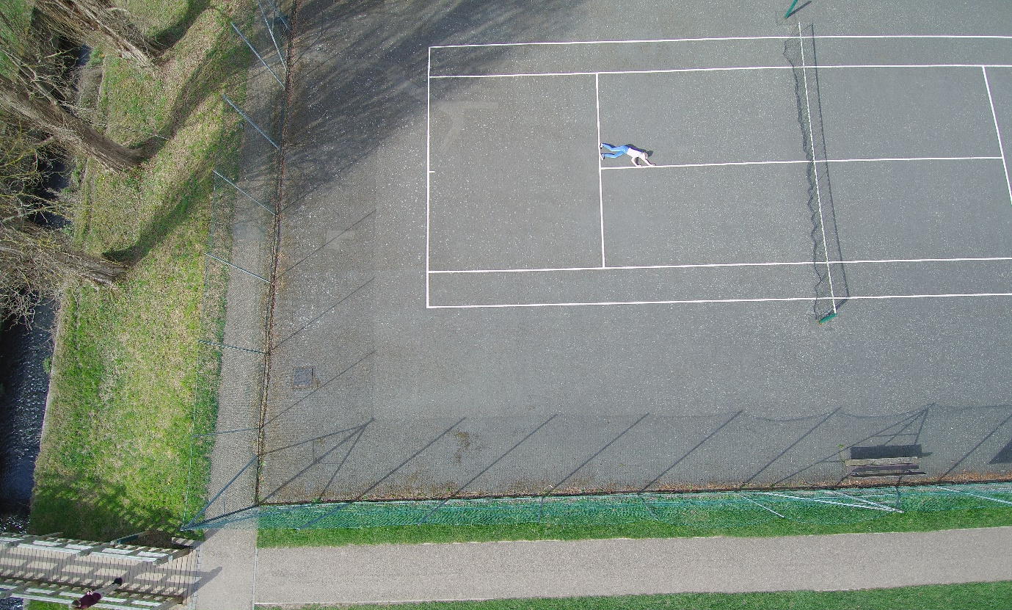Finally, pressed against the vertical middle line **[see Figure 7]**. These four positioned were photographed three or four times each to account for errors.

Figure

To reflect, the flight went well and once a good position was found the mission was simple with the drone staying quite still due to the low winds recorded on the checklist as 3.1 mph. Originally, a mistake occurred during the first few photographs, the drone was not capturing the whole width of the court which would of ruined my final artefact and so adjustments to the drone’s position had to be made resulting in different angles for each photo making it harder to edit together. Nevertheless, the latter photos were taken from identical positions thus reducing the editing required.

On the topic of editing, I used Adobe Photoshop to create the artefact. This involved multiple tools including:

* Align
* Brightness + Contrast
* Clone
* Copy
* Delete
* Distort
* Dodge + Burn
* Exposure
* Flipping
* Hue + Saturation
* Levels
* Magic wand
* Masking
* Rotation
* Ruler
* Selection
* Warp

**Process**

Sadly, only some of these tools produced the desired effects and others whilst working for some areas of the artefact, did not work well in other areas. The first stage of creating this artefact was to adjust the original images. Due to the position of the drone the images were horizontal and not actually flat therefore, to create a tennis court that looked like a tennis court, it was essential to **distort** the image. Originally, I tried to **warp** the image at this stage however, this failed due to the stretched and uneven results whereas distort was both simple and effective for the outcome I desired. Once the image looked flat, I needed to turn the image, so it looked more like the model was trapped especially inside the hanging photo and therefore, I **rotated** the image 90° and **cropped** to leave only the tennis court inside the canvas.

This was repeated on all four photos of the model, although it was later revealed to me that this was a mistake and that I could just reshape sections of the image so that the model would look realistic as the rest of the image would eventually be cut out. The images then needed to be layered on top of each other as the original plan was to create **clipping masks** so that the model on each image was visible through other layers. This idea was scraped due to a much simpler solution being discovered: Deletion. Wherever the model was positioned, a hole would be **deleted** out of the above layer/layers, so the model was visible through the cut gap. This worked well due to their similar backgrounds however, it did take time to position each layer perfectly so that the lines of the court lined up correctly. A tool that did not work well was the **ruler** tool, which is meant to align items however, when this was used the layers were completely skewed, perhaps due to the difference in distortions. Regardless, this led to very unaligned images if adjustments occurred at all.

Once the images were visible through the deleted areas and the lines were aligned manually, an issue occurred - due to the slight time gaps of each photo there was subtle differences in light meaning that the court required colour adjustments to look similar. This process involved the use of **levels** which worked amazingly, with some very subtle adjustments to the brightness levels allowing a clear match amongst colours. I attempted to imitate this technique using **brightness** and **contrast** controls, but nothing worked as well as the levels tool did for this.

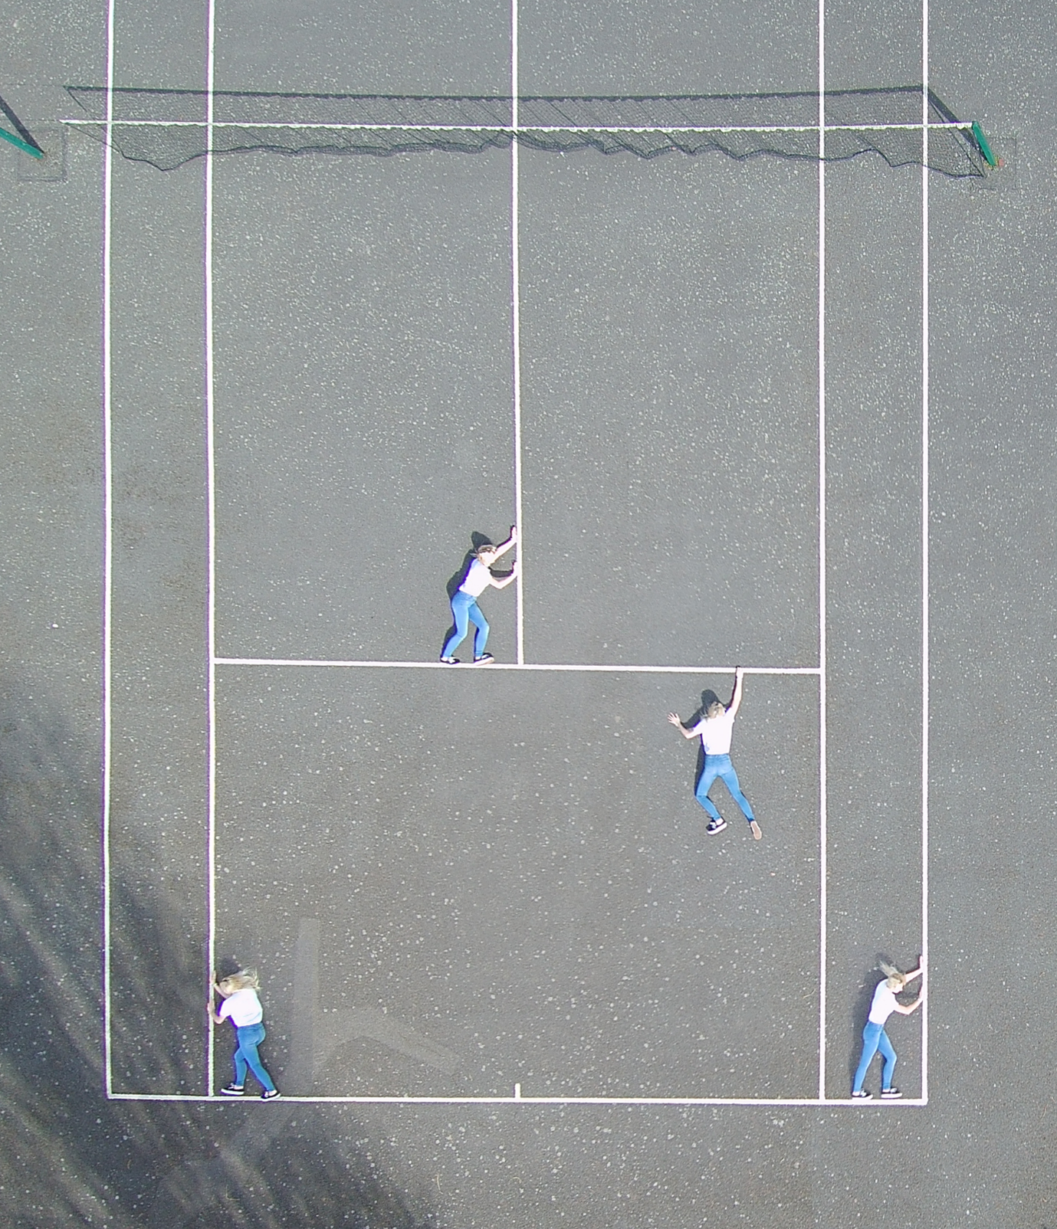

Figure

Whilst this artefact was pleasing **[see Figure 8]** and served the purpose intended for it, I wanted to challenge myself further and produce a more advanced artefact using even more tools and techniques. This led to the duplication of the image so that it looked like a full tennis court which also helped to create the illusion that the image was taken from directly above the centre of the court. This duplication was done by **copying** the tennis court, **flipping** the image vertically and horizontally and then joining the images at the netting by deleting any extra court that sat between the images **[see Figure 9].** The duplicated people needed to be replaced as they were now upside down which moved away from the original plan and therefore, these were edited out originally through **deleting** and making the area content aware, thus filling it with whatever Photoshop believed to be a suitable replacement for the area. However, this failed in many areas leading to a different tactic - **cloning**. Selecting empty areas manually elsewhere and painting them over with the clone tool allowed the desired areas to be covered in tennis court rather than the model **[see Figure 10].**

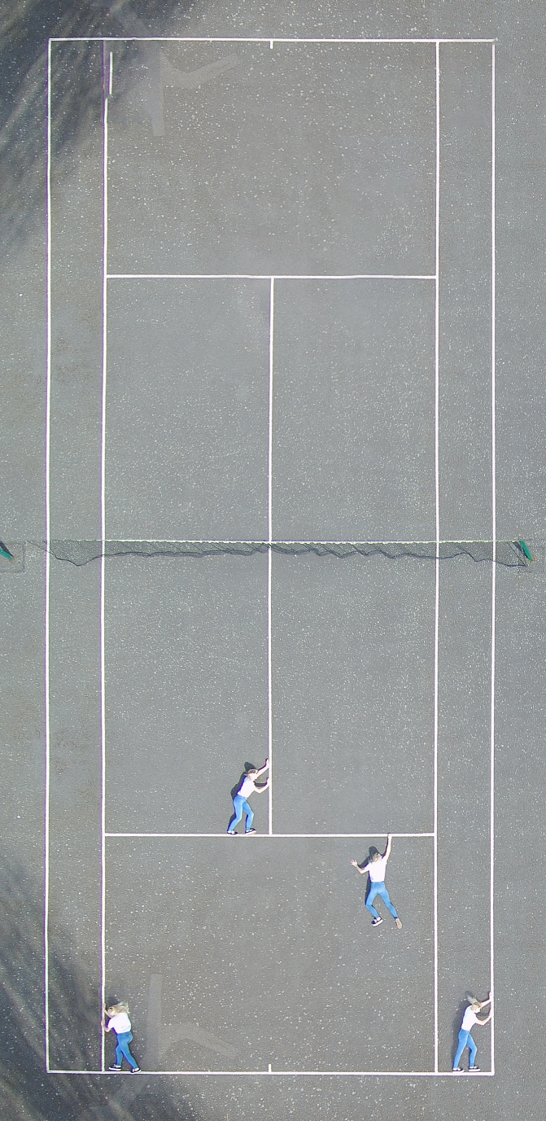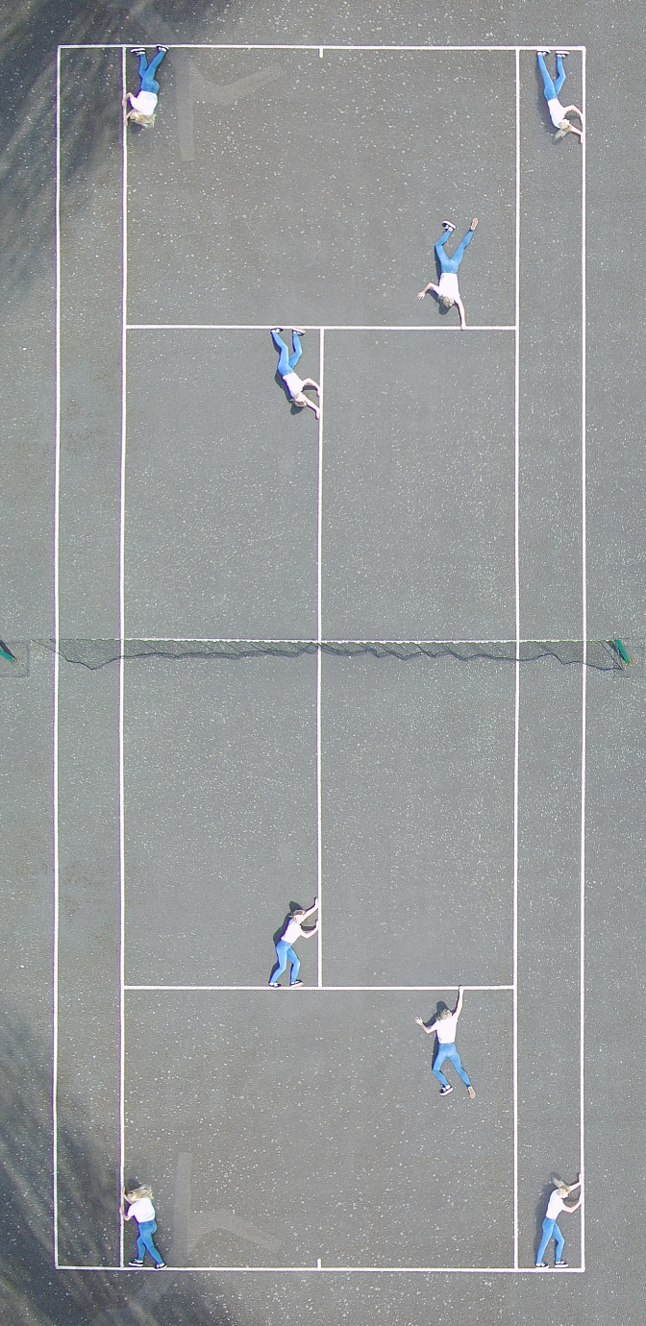

Figure

Figure

Once cleared, the models were also copied over to the alternative side but to differentiate them the **magic wand** helped select the jeans and their **hue + saturation** was altered making the trousers turn green. These new models were again placed in positions that looked like they were trapped and trying to break out of their boxes. With this side of the court, the shadow of the trees had to be removed to make it less obvious it was the same image reversed. Therefore, a combination of the **dodge** and **burn** tools were tried to darken this area so it looked more natural however, the solution came in the form of **cloning** again allowing the court to be copied over from the light side to the shadow etching out the dark areas and replacing it with light grey. This led to a different problem as the lines no longer looked right and consequently, they had to be retouched via **cloning** at a size of 1px and then the **dodge** tool helped to brighten the lines.

This finalised the product **[see Figure 11]**. Whilst lots of mistakes occurred, particularly in the form of incorrect tools being used, the production of the artefact was quite successful. Nevertheless, there is always room for improvement thus if I was to repeat this project, I would adjust how the model poses to offer more customizable designs. Additionally, despite the drone’s camera supposedly having auto-exposure mode on, the pictures came out very washed out and the model’s face is completely white so next time I would either adjust the exposure settings manually or triple check the drone’s view before taking pictures.

Furthermore, regarding editing, I would triple check all lines were connected and that no bumps or dents occurred as the distortion and cloning did skew some lines marginally. Moreover, I would remove the netting as I believe the image would look better with a straight line down the middle rather than the wavy net, which is the only aspect that suggests the photo was not taken from directly above the court. Or perhaps, go even further creativity wise and use a blank floor and draw the tennis court lines via Photoshop as an extra challenge. This may also help keep the lines perfectly straight and pure white also allowing the customization of floor colour again allowing further creativity.

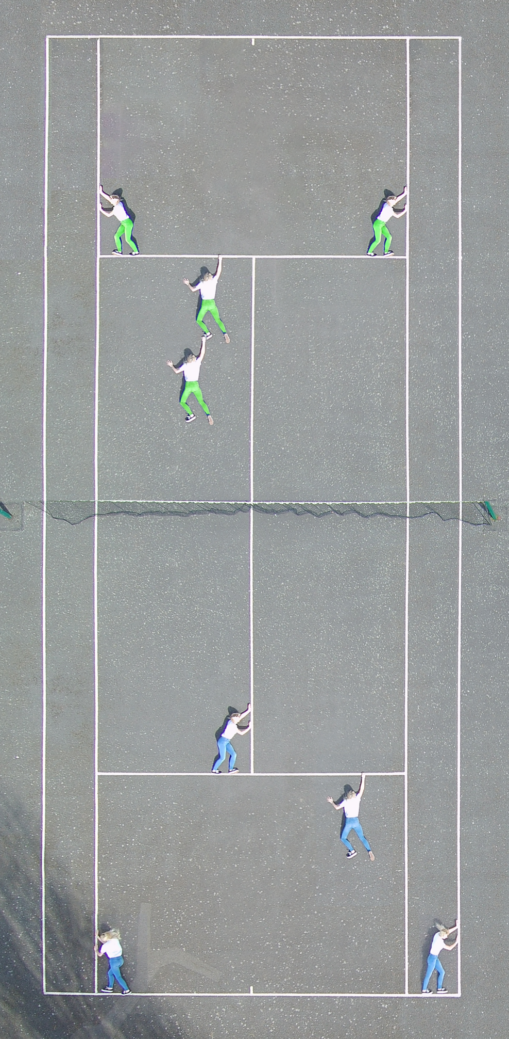**Final Artefact**

Figure

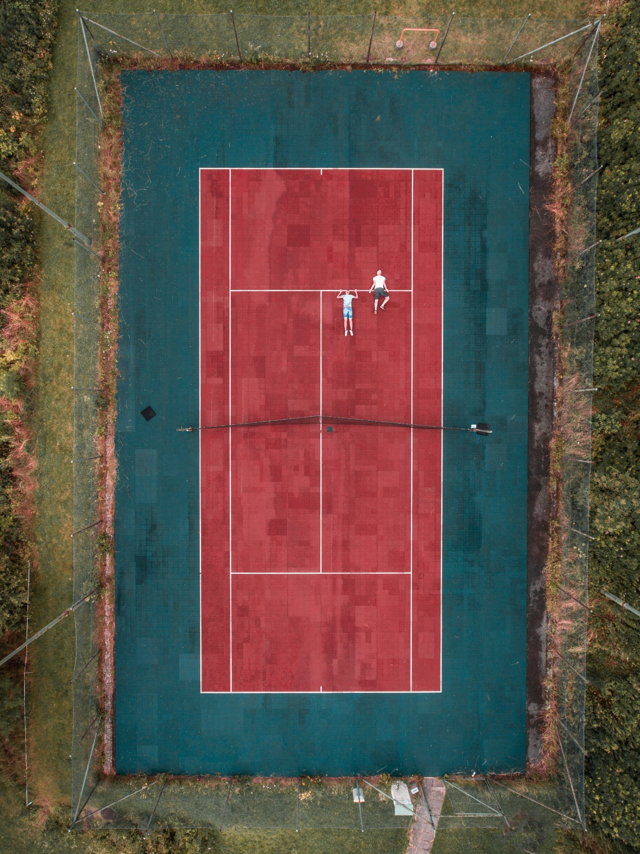**Other examples**

Figure - (Streefkerk 2017)

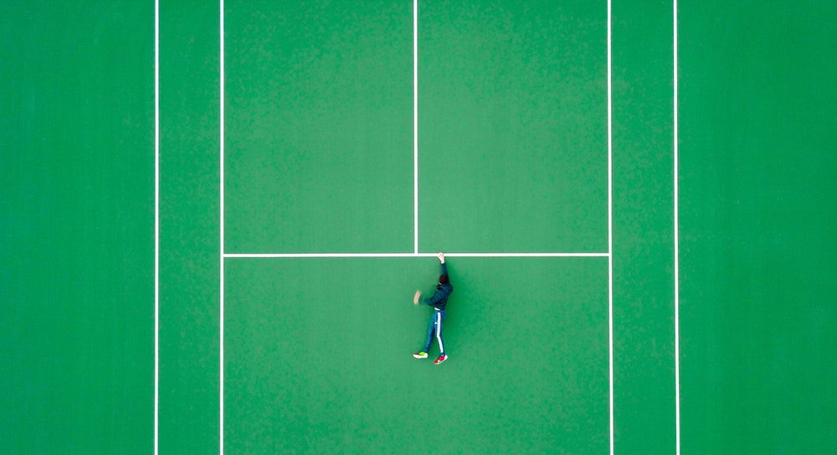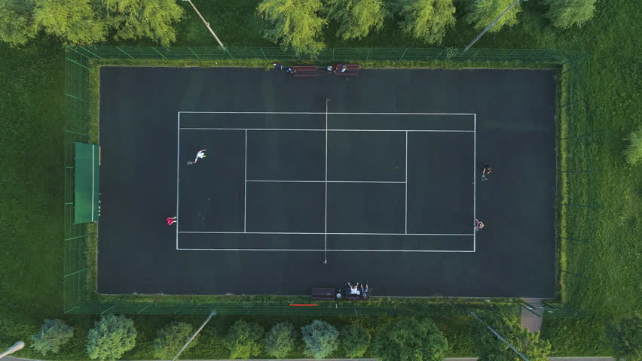

Figure - (Sanchez 2017)

Figure – (mzabarovsky 2018)

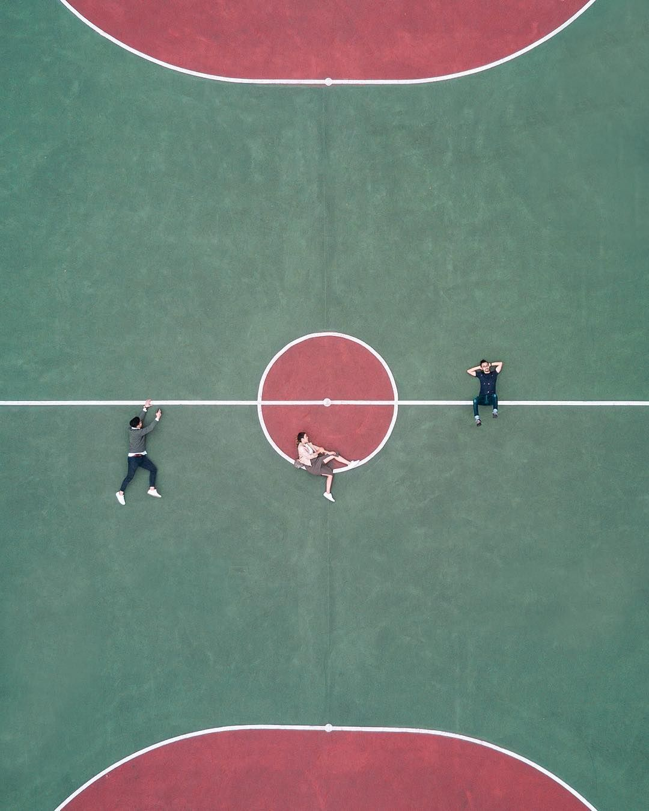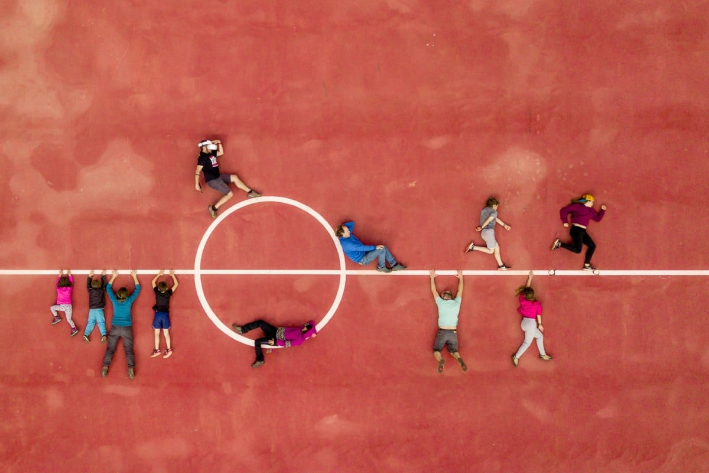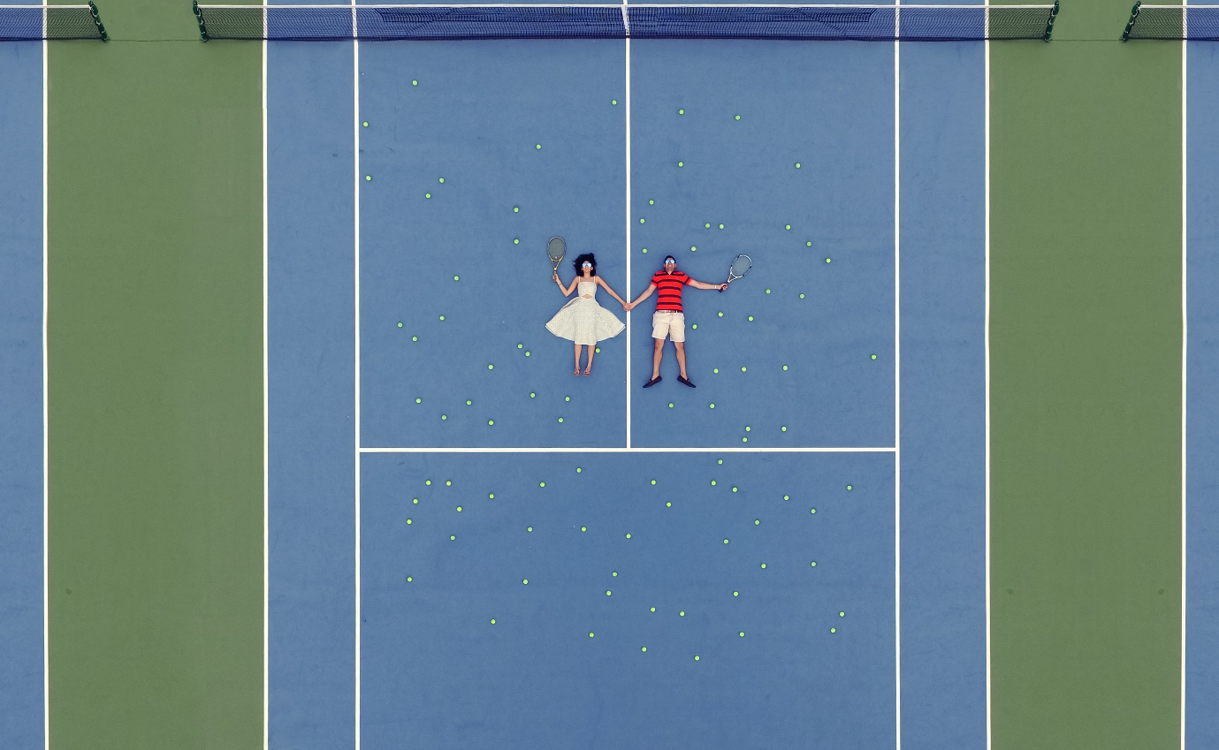

Figure - (photogrist 2017)

Figure - (Dronestagram 2019)

Figure - (Rathi 2017)

**Comparison**

The main difference between the finished artefact and other people’s artefacts available online is mostly the colours. Many of the images I found contained colourful courts with all of them having either brightly coloured courts or brightly coloured surroundings adding the beauty of the photos. Additional differences are visible with the lack of editing required in other photos due to the different models posing rather than a repeated model placed in several locations. Whilst I like the aesthetic of these types of photos, I prefer the complexity and uniqueness of duplicated models particularly with the different coloured trousers.

**Figure 14** did inspire me to perhaps use the tennis court as a tennis court next time and organise the model to pose in tennis stances or use props such as racquets and tennis balls to create a different type of artefact. Similarly, **Figure 15** (photogrist 2017)and **Figure 16** (Dronestagram 2019)both offer the suggestion that a different type of court could provide a fresh approach as basketball courts tend to have more complex lines such as the centre circle which would provide further challenges when editing.

Overall, I believe that my final artefact is both more complex and attractive in comparison to the other examples even with the dull court colours as this helps focus the attention on the model and unlike some of the other examples the photos are still in focus. Although, next time the exposure would ideally be fixed so that the model is not washed out and would look more like the clear-cut model seen in other examples.

**Relationship to future drone technology**

Even though this drone flight worked well and met the predicted outcomes, in the future there may be techniques that make this task easier or improve the quality. For example, new drones may introduce flight modes that require less control with current models such as the **Altair Outlaw, DJI Mavic 2 Pro** andthe **DJI Phantom 4 Professional** (Dronethusiast 2019) offering auto-pilot mode that controls the flying itself. Whilst the **Yuneec Typhoon H** that was used to produce the artefact has autopilot mode also known as *“autonomous flight modes”* (Typhoon-H 2019) it was not used for this project due to the expected simplicity of the flight path.

Auto-pilot would only be a great improvement if collision detection improves further, and location data keeps improving in accuracy as well. Without these enhancements drone crashes will only increase as drones fly into tree branches or fences or even people if their collision detection is bad/non-existent. According to (Grigonis 2016) 64% of drone crashes are caused by technical errors which shows that this is an area that needs to advance quickly. This is a likely improvement with protective measures being a focus for many companies in the form of propeller guards, bumper feet, shock absorbent bodies and blunt plastic propellers (Brown 2019).

Or taking auto-pilot one step further, advancements such as, a mode that automatically takes pictures when it arrives at the pre-set location. This would allow the pilot to be the model rather than having two separate people performing the tasks. This feature is in fact available on some drones with the ‘DJI Go App’ allowing pilots to instruct their drone to take a photo every 10, 20 or 30 seconds which whilst not as customizable as one would hope would present an excellent opportunity to be both pilot and model. A more advanced version of this has recently come out of beta testing and is aimed at those creating 3D models but would also work for this project as once instructed, the drone follows the predetermined path and takes continuous photos (Pix4dcapture 2019).

Additionally, progress may occur with automatic image combining, this technique may allow the drone to take several photos and instantly merge them together producing artefacts comparable to my own but without the need for editing software and offering a copy of the final artefact within minutes of landing from the flight. Sadly, there is no evidence of this being offered any time soon with most research around this focusing on the editing software that will be used post flight rather than during the flights (Shang 2018).

Alternatively, drone laws may change over time perhaps becoming less restrictive allowing flights to be within a closer proximity of buildings that are not under the pilots control. This would have allowed the flight to hover over the centre of the court, again reducing the editing required. In other projects, this alleviating of laws may lead to more interesting photos in locations previously unavailable for flights.

Finally, as time progresses, drone cameras are bound to improve and with better cameras should come better photos. Having more advanced cameras such as the current latest phone cameras would allow impeccable zoom functionality, clearer photos with better exposure and lighting options all leading to higher quality artefacts in the future.

# **References**

Brown, J. (2019) *DRONE TRENDS: WHAT WILL THE FUTURE HOLD FOR DRONES AND DRONE FLIGHT?* [Online] Available from: <http://mydronelab.com/blog/drone-trends.html> [Accessed 13 April 2019].

Dronestagram (2019) *My Modern Met*. [Online] Available from: <https://mymodernmet.com/dronestagram-drone-photography-contest/> [Accessed 12 April 2019].

Dronethusiast (2019) *Best Autopilot Drones [2019] Top 7 Drones With Autopilot Reviews*. [Online] Available from: <https://www.dronethusiast.com/best-autopilot-drone-reviews/> [Accessed 13 April 2019].

Grigonis, H. (2016) *Drone crashes caused by technical glitches*. [Online] Available from: <https://www.digitaltrends.com/cool-tech/drone-crashes-caused-by-technical-glitches/?utm_source=feedly&utm_medium=webfeeds> [Accessed 13 April 2019].

mzabarovsky (2018) *shutterstock*. [Online] Available from: <https://www.shutterstock.com/video/clip-28160107-players-play-tennis-on-green-court-aerial> [Accessed 12 April 2019].

photogrist (2017) *Photogrist Photo Magazine*. [Online] Available from: <https://photogrist.com/lifestyle-instagrams-victor-cheng/> [Accessed 12 April 2019].

Pix4dcapture (2019) *Plan and control drone flights using only your mobile phone*. [Online] Available from: <https://www.pix4d.com/product/pix4dcapture> [Accessed 13 April 2019].

Rathi, A. (2017) *Reels & Frames*. [Online] Available from: <https://reelsandframes.in/couple-portraits/> [Accessed 12 April 2019].

Sanchez, M. (2017) *Unsplash*. [Online] Available from: <https://unsplash.com/photos/x-rqS-3Qi10> [Accessed 12 April 2019].

Shang, M. (2018) *How to Mask Anything in a Snap Using Lightroom’s Auto Masking*. [Online] Available from: <https://petapixel.com/2018/06/04/how-to-mask-anything-in-a-snap-using-lightrooms-auto-masking/> [Accessed 15 April 2019].

Streefkerk, K. (2017) *Unsplash*. [Online] Available from: <https://unsplash.com/photos/khFMGeuBy-s> [Accessed 12 April 2019].

Typhoon-H (2019) *Typhonn-H Overview*. [Online] Available from: <https://www.yuneec.com/en_GB/camera-drones/typhoon-h/overview.html> [Accessed 13 April 2019].